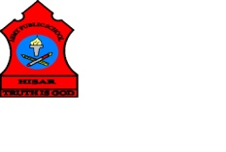
ARMY PUBLIC SCHOOL HISAR
Topic: CH-4, ‘PLANTS, OUR GREEN FRIENDS’
Subject: EVS
Worksheet No: 2
Class: III
Number-9
- Complete the following one word answer by using the help box given below:
Veins Lamina/Leaf blade Trunk Roots

- Parts of a plant below the ground. _____________
- The thick and strong stem of big trees. _____________
- Several lines that run across the leaves. _____________
- The flat part of the leaf. _____________
B. Collect few different types of leaves from your garden and paste in the Notebook. Also write the name of the leaf.

______________________ ______________________

______________________ _________________________
C. Draw and label the diagram of Germination of a seed.

