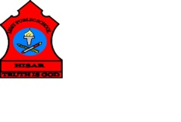
ARMY PUBLIC SCHOOL HISAR
Topic- CH-14, MEANS OF TRANSPORT
Subject: EVS
Worksheet No: 2
Class: III
Number-20
- Draw and colour two each of Land, Air and Water transport.

LAND TRANSPORT

AIR TRANSPORT

WATER TRANSPORT

