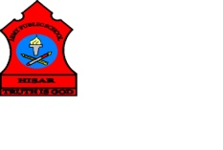
ARMY PUBLIC SCHOOL HISAR
Topic- CH-14, MEANS OF TRANSPORT
Subject: EVS
Worksheet No: 1
Class: III
Number-19
- Fill in the blanks using correct options:
- To catch a bus we go to the ___________.
- Bus stand b. railway station c. airport
- The fastest means of transport is ___________.
- Bus b. steamer c. aero plane
- The place where ships load and unload is called a __________.
- Port b. airport c. station
- The vehicle which can move on water is the ____________.
- Steamer b. car c. train
- The most common means of transport is _________________.
- Land transport b. air transport c. water transport

- Match the following:

