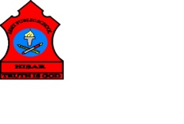
ARMY PUBLIC SCHOOL HISAR
Topic- CH-11, A FRIENDLY NEIGBOURHOOD
Subject: EVS
Worksheet No: 2
Class: III
Number-16
- Choose the right answer from the given cloud and fill in the blanks:
BANK PARK POST MAN
COMFORTABLE
SAFE NEIGHBOURHOOD

- A _______________ delivers letters, cards, telegrams and money orders.
- We keep our money and precious things safely in a ___________.
- We should not pluck flowers or plants when we go out to play in a ___________.
- It is our duty to keep our ________________clean.
- Neighbourhood services have made our life _____________ and _________________.

