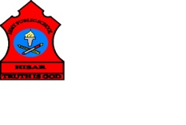
ARMY PUBLIC SCHOOL HISAR
Topic: CH-4, ‘PLANTS, OUR GREEN FRIENDS’
Subject: EVS
Worksheet No: 1
Class: III
Number-8
A. Tick the correct answer:
- The lungs of the planet are________.
- Sea animals b. plants c. factories
- Plants which have a hard and thick stem and which grow tall are_________.
- Shrubs b. herbs c. trees
- Fenugreek and coriander are the examples of__________.
- Shrubs b. herbs c. trees
- It is a form of root, it stores food__________.
- Wheat b. potato c. turnip
B. Draw and label the diagram of Parts of a tree in your Notebook.
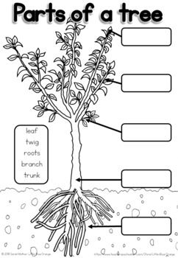
C. Draw two different types of Roots.

__________________ ____________________

