ARMY PUBLIC SCHOOL HISAR
Topic: ‘Recreation’
Subject: EVS
Ch-3, Text Book exercise and question/answers
Class: III

- Fill in the blanks using correct options:
- Activities keep our mind and body healthy and happy.
- Painting and sculpture are example of creative arts.
- Dancing and singing are examples of performing arts.
- Cricket is an outdoor game.
- Sachin Tendulkar made his hobby cricket his profession.
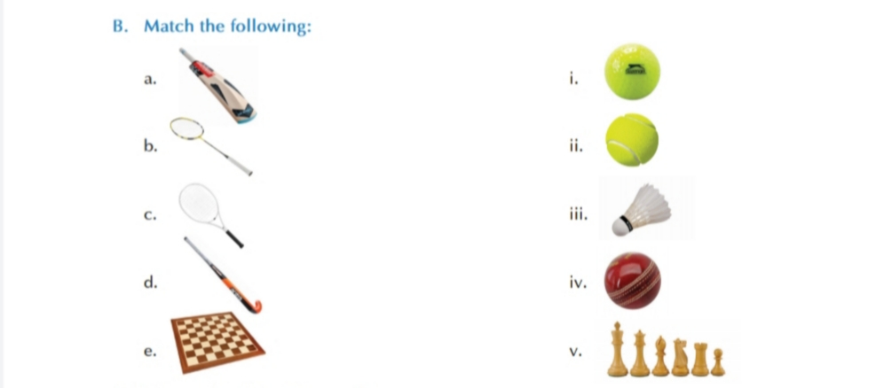
- Answers of match ups
- - iv
- – iii
- – ii
- – i
- – v
- Answer the following questions:
Q.1. Why should we play outdoor games?
Ans. We should play outdoor games to keep ourselves physically fit and active.
Q. 2. What are Performing Arts?
Ans. Performing Arts: - When we spend our time by being creative or doing some creative activities. For example: - Clay modeling, painting and embroidery.

